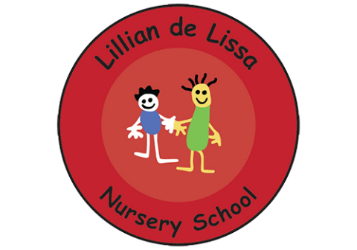
Lillian De Lissa Nursery School,
Bellevue, Edgbaston
Birmingham, B5 7LX
Tel: 0121 675 3421
Email: enquiry@ldelissa.bham.sch.uk
Executive Head Teacher: Mandy Cryan

Wednesday 12th May 2021
Hello everyone!
This week the children at Lillian selected the box of wild animals to play with on the construction area. This has led to opportunities to build houses for them.
We’ve seen the animals crossing a bridge too - it’s the influence of the Three Billy Goats Gruff storytelling in their play which is lovely to see!
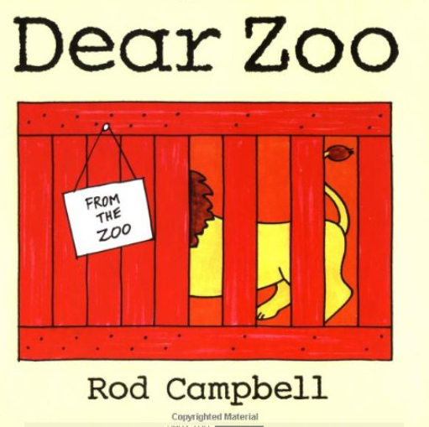
A wonderful story about a child getting a delivery of different animals to play with can be found here - Dear Zoo.

https://youtu.be/ZqGYWRHOV6E

Another lovely version is here:

https://youtu.be/UywEnHKTMXk

Animals are sent that are too...grumpy, jumpy, naughty, fierce, scary...
It’s a great book for learning these describing words.
Watch together and ask your child if they could choose - which animal would they like to have? Why? Which animal would you like?
Some of our children came to school very excited about Eid - talking about looking for the special moon and showing us their beautiful mendhi patterns on their hands and arms.
Eid Mubarak to everyone celebrating- we can’t wait to hear all about it!
0121 675 3421 - ask to speak to Mrs Appadu.
Kind regards,
All the team at Lillian de Lissa

